

**CAPSTONE PROJECT 1**

**English For You**

**USER INTERFACE DESIGN DOCUMENT**

Version 1.0

Date: Oct 19, 2018

**MENTOR:** Truong Tien Vu

**MEMBER**: Tran Nguyen Huu Nghia

Do Van Truong

Doan Nu Thuc Oanh

Dinh Tran Anh Truc

**INTERNATIONAL SCHOOL**

**Project Information**

|  |  |  |  |  |  |
| --- | --- | --- | --- | --- | --- |
| **Project acronym** | Eng4you | | | | |
| **Project Tittle** | [E4U] English For You | | | | |
| **Start Date** | Oct 19, 2018 | | **End Date** | | Oct 19, 2018 |
| **Lead Institution** | International School, Duy Tan University | | | | |
| **Project Mentor & contact details** | Mr. Vu Truong Tien  Email: vudalat@yahoo.com  Tel: 0914083188 | | | | |
| **Scrum Master & contact details** | Nghia ,Tran Nguyen Huu  Email: trannguyenhuunghia97@gmail.com  Tel: 0934848229 | | | | |
| **Team members** | **Name** | **Email** | | **Tel** | |
| Truong, Do Van | [Truongdtct1230@gmail.com](mailto:Truongdtct1230@gmail.com) | | 01674275453 | |
| Oanh, Doan Nu Thuc | [Doannuthucoanh0410@gmail.com](mailto:Doannuthucoanh0410@gmail.com) | | 01674552075 | |
| Truc, Dinh Tran Anh | [Anhtruc2091997@gmail.com](mailto:Anhtruc2091997@gmail.com) | | 0947360347 | |

**User Interface Design Document**

|  |  |  |  |
| --- | --- | --- | --- |
| **Document Title** | **User Interface Design** |  |  |
| **Reporting Period** | Oct 19,2018 |  |  |
| **Author(s) &**  **project** | Nghia ,Tran Nguyen Huu  Scrum Master | |  |
| **Team Information** | **Name** | **Role** |  |
| Truong, Do Van | Member |  |
| Oanh, Doan Nu Thuc | Member |  |
| Truc, Dinh Tran Anh | Member |  |
| **Date** | 28 Aug, 2018 | **Filename** | [E4U]User Interface Design Document_Ver1.0.docx |
| **Access** | Project and CMU Program | |  |

**REVISION HISTORY**

|  |  |  |  |
| --- | --- | --- | --- |
| **Version** | **Person** | **Date** | **Description** |
| V1.0 | Team | Sep 12, 2017 | Draft for Document |

**Document Approvals**

The following signatures are required for approval of this document.

|  |  |  |
| --- | --- | --- |
| MSc. Vu, Truong tien  *Mentor & Product Owner* |  | Date: Oct 19, 2018 |
| Nghia, Tran Nguyen Huu  *Scrum Master* |  | Date: Oct 19, 2018 |

Contents

**1.** **Overview** 6

1.1. Purpose 6

1.2. Related Documents 6

**2.** **Interface Design** 7

2.1 Home page 7

2.2 Register 7

2.3 Login 8

2.4 Product detail 8

2.6 Cart 9

2.7 User Information 10

2.7.1 Update Information 10

2.7.2 Change password 10

2.7.3 View history transaction 11

2.8 Login Admin 11

2.9 Home Admin 12

2.10 Transaction 12

2.11 Order 13

2.12 Product & Catalog 13

1. **Introduction**
   1. **Purpose**

* This document describes the design interface of “E4U English For You Web” System.
  1. **Scope**
* Overview of the stages and modules of the software.
* Create complete interfaces, and describe them clearly.
  1. **Related Documents**

• [E4U]ProductBacklog

• [E4U]ArchitecutreDocument

•.[E4U]DatabaseDesign

1. **List of User Interface for Sprint**

|  |  |  |  |  |
| --- | --- | --- | --- | --- |
| Roles | User Interface ID | UI Name | Description | Notes |
| User | UI-01 | Home Page | This form show to home page of the system (imformations,funcitions,…) |  |
| User | UI-02 | Login | This form is used for user to login the system. |  |
| User | UI-03 | Word Explain Wait page | This Page is used to display the wait interface when users connect with others player |  |
| User | UI-04 | Word Explain Play page | This page is used to display a game interface for player |  |

1. **Describe User Interface for All**
   1. **UI-01: Sign In**

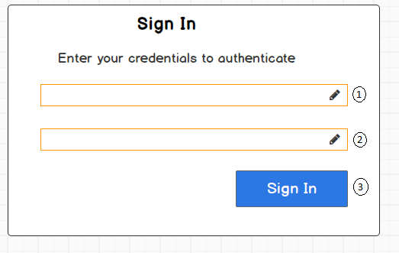

|  |  |  |  |  |  |
| --- | --- | --- | --- | --- | --- |
| From | Condition | Null | Control Type | Target | Notes |
| 1 | Input |  | Textbox | Input user’s email |  |
| 2 | Input |  | Textbox | Input user’s password |  |
| 3 | Click |  | Button | Click to login into the dashboard |  |

* 1. **UI-02: Sign Out**

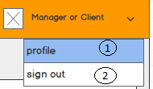

|  |  |  |  |  |  |
| --- | --- | --- | --- | --- | --- |
| From | Condition | Null | Control Type | Target | Notes |
| 1 | Click |  | Button | Click to view user's profile |  |
| 2 | Click |  | Button | Click to logout out of application |  |

* 1. **UI-03: Profile**

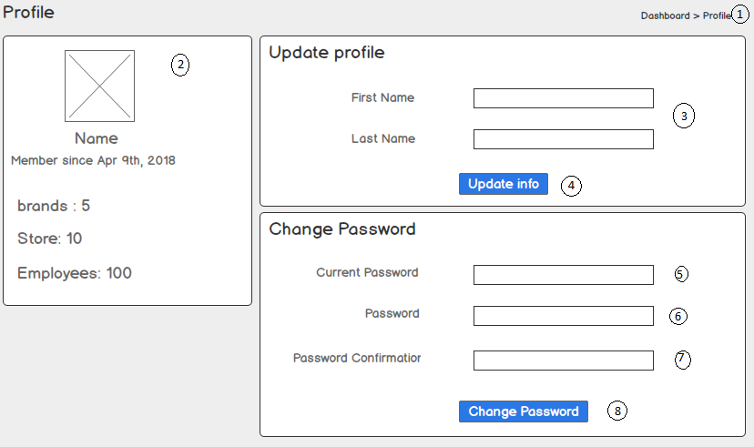

|  |  |  |  |  |  |
| --- | --- | --- | --- | --- | --- |
| From | Condition | Null | Control Type | Target | Notes |
| 1 | View |  | Breadcrumb | Show path index |  |
| 2 | View |  | Section | Display user’s profile( total brands, stores, Employees) |  |
| 3 | Input |  | Text | Input First Name, Last Name |  |
| 4 | Click |  | Button | Click to update the information |  |
| 5 | Input |  | Text | Input Curent Password |  |
| 6 | Input |  | Text | Input New Password |  |
| 7 | Input |  | Text | Input Password Confimation |  |
| 8 | Click |  | Button | Click to change password |  |